Instruction for image acquisition:

1. At least 8 MP camera is needed to take good quality image for detecting counterfeit bank notes of Bangladesh.



2. Please press the button to acquire the relevant note image using camera. You may also choose image from SD card using button. This application uses external camera module. So it may ask you to choose a camera module from a list.

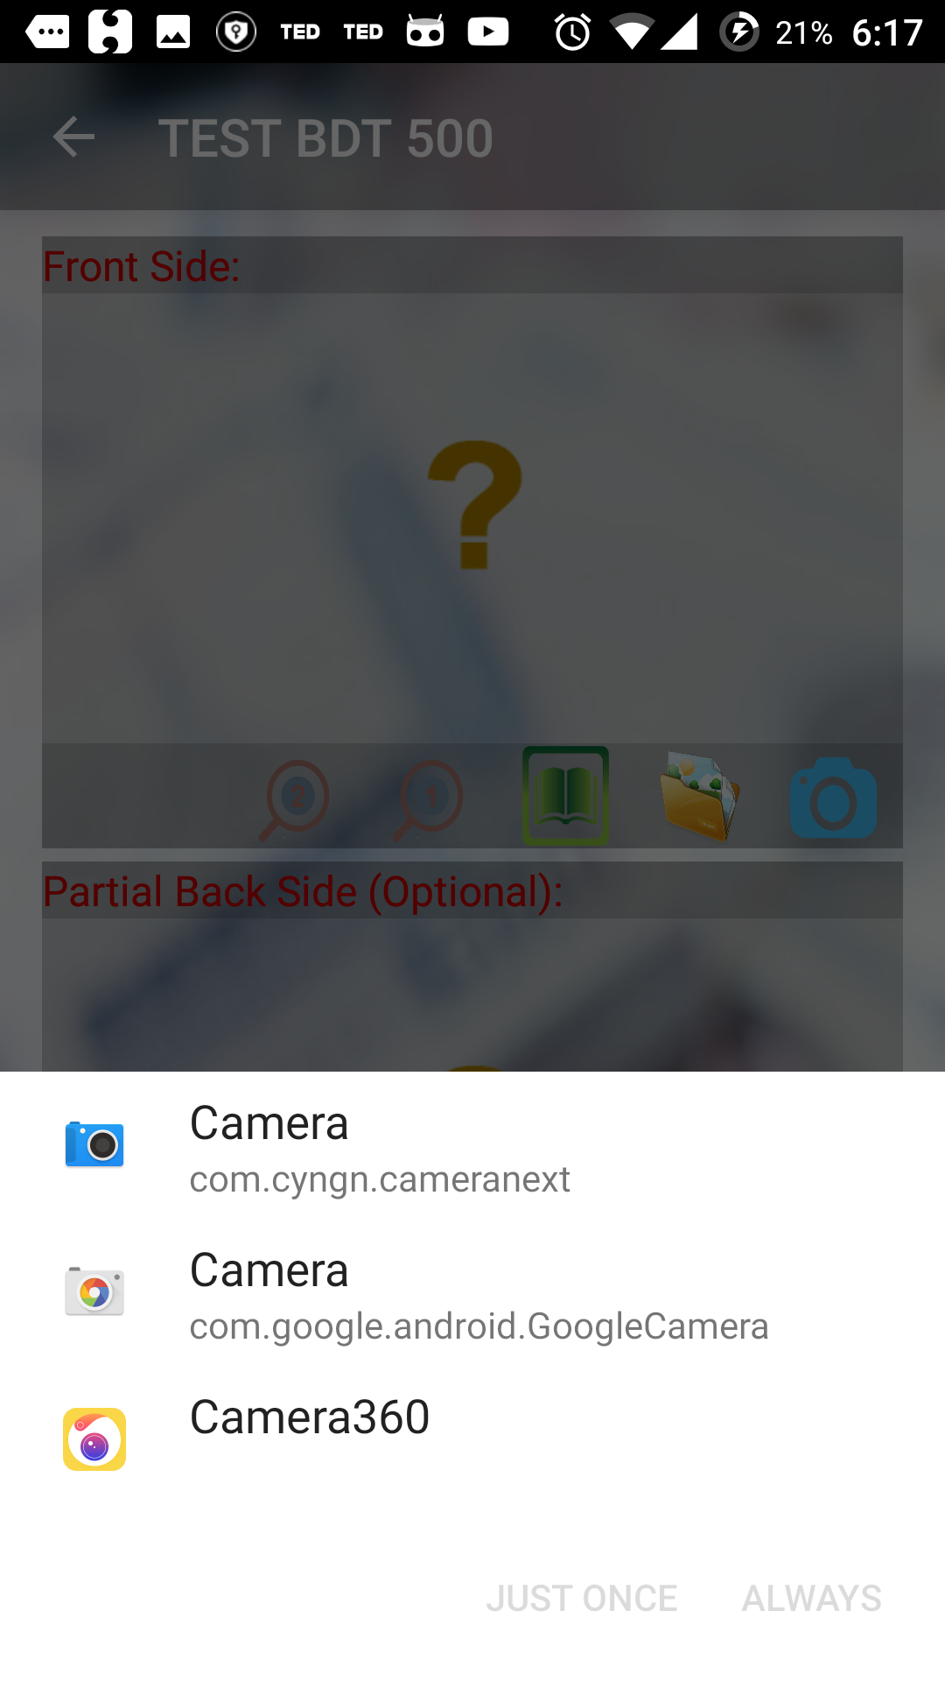

It is better to use system camera module to take picture. Do not use camera modules like Beauty Cam, Camera360 etc. After selecting appropriate camera, press always if you do not want to be asked the same thing again. On the following screen approve all the permission.

3. Here you only need to take partial image (one third of the whole back side). Some correct ways to take partial back image of the note are given below:

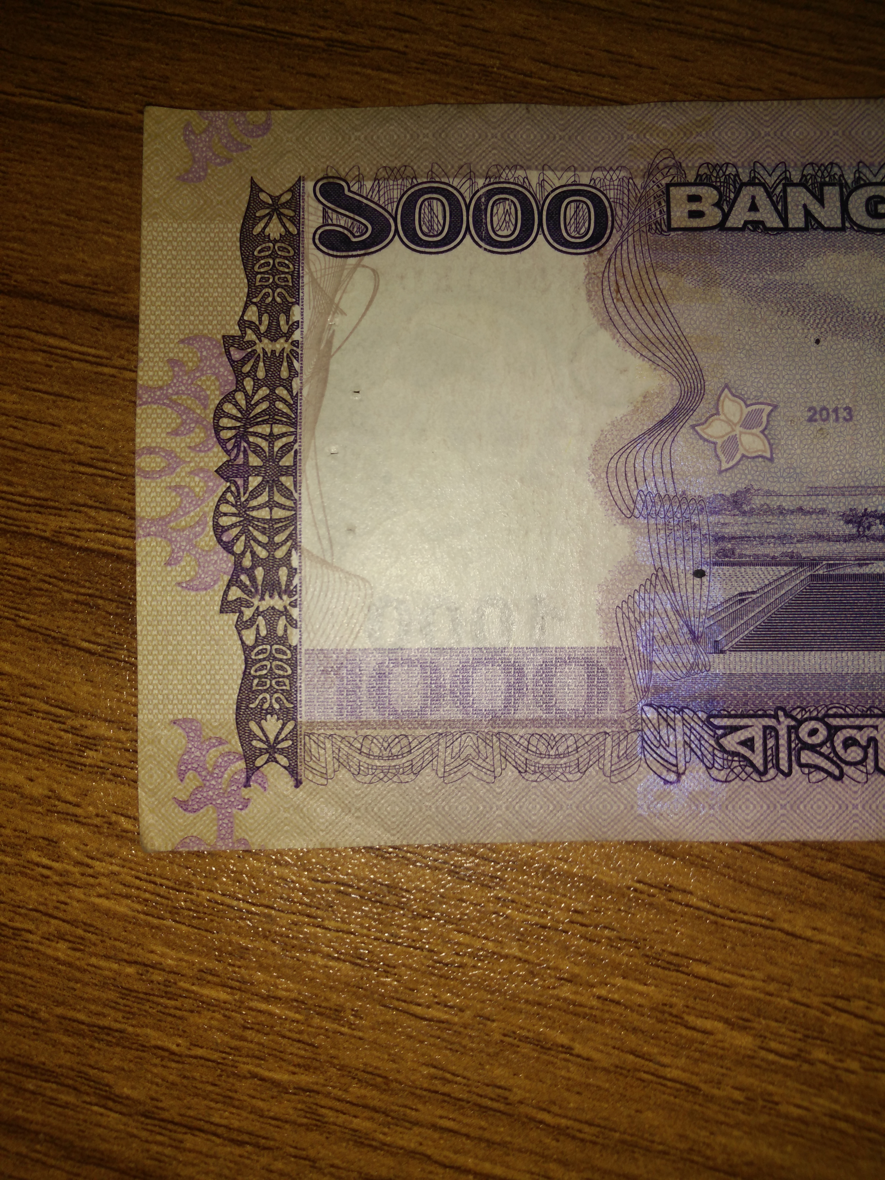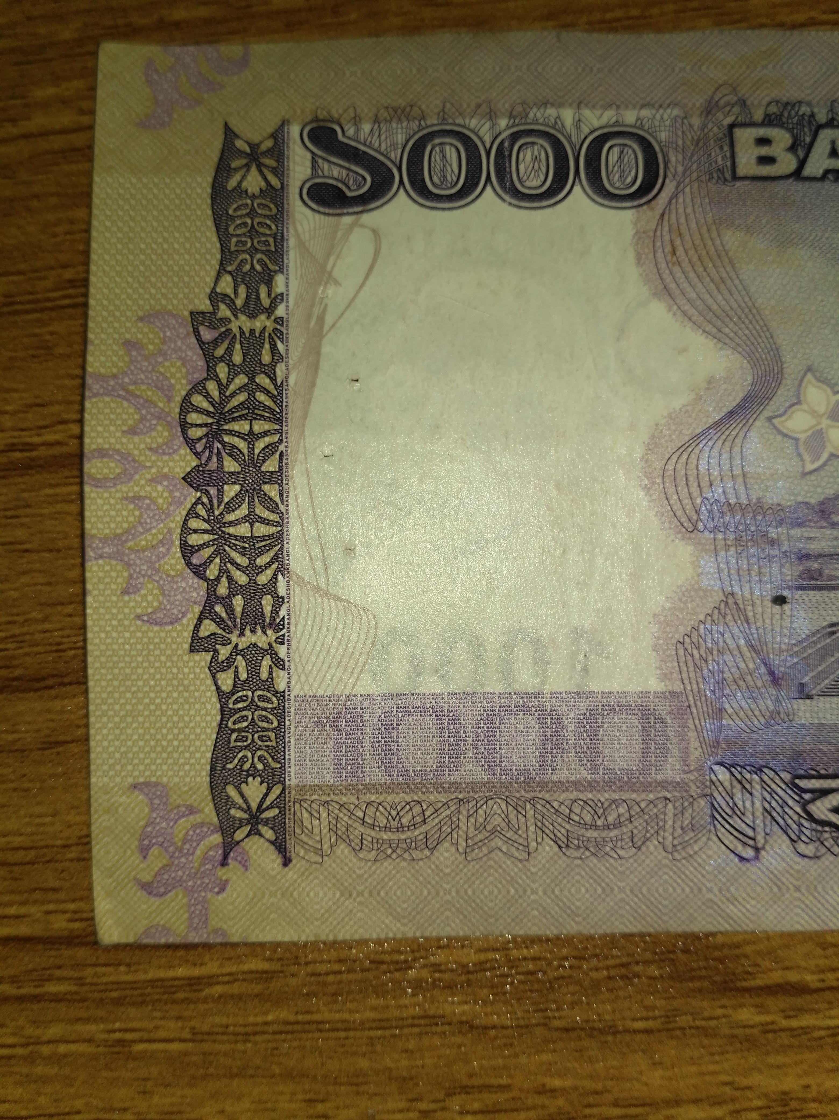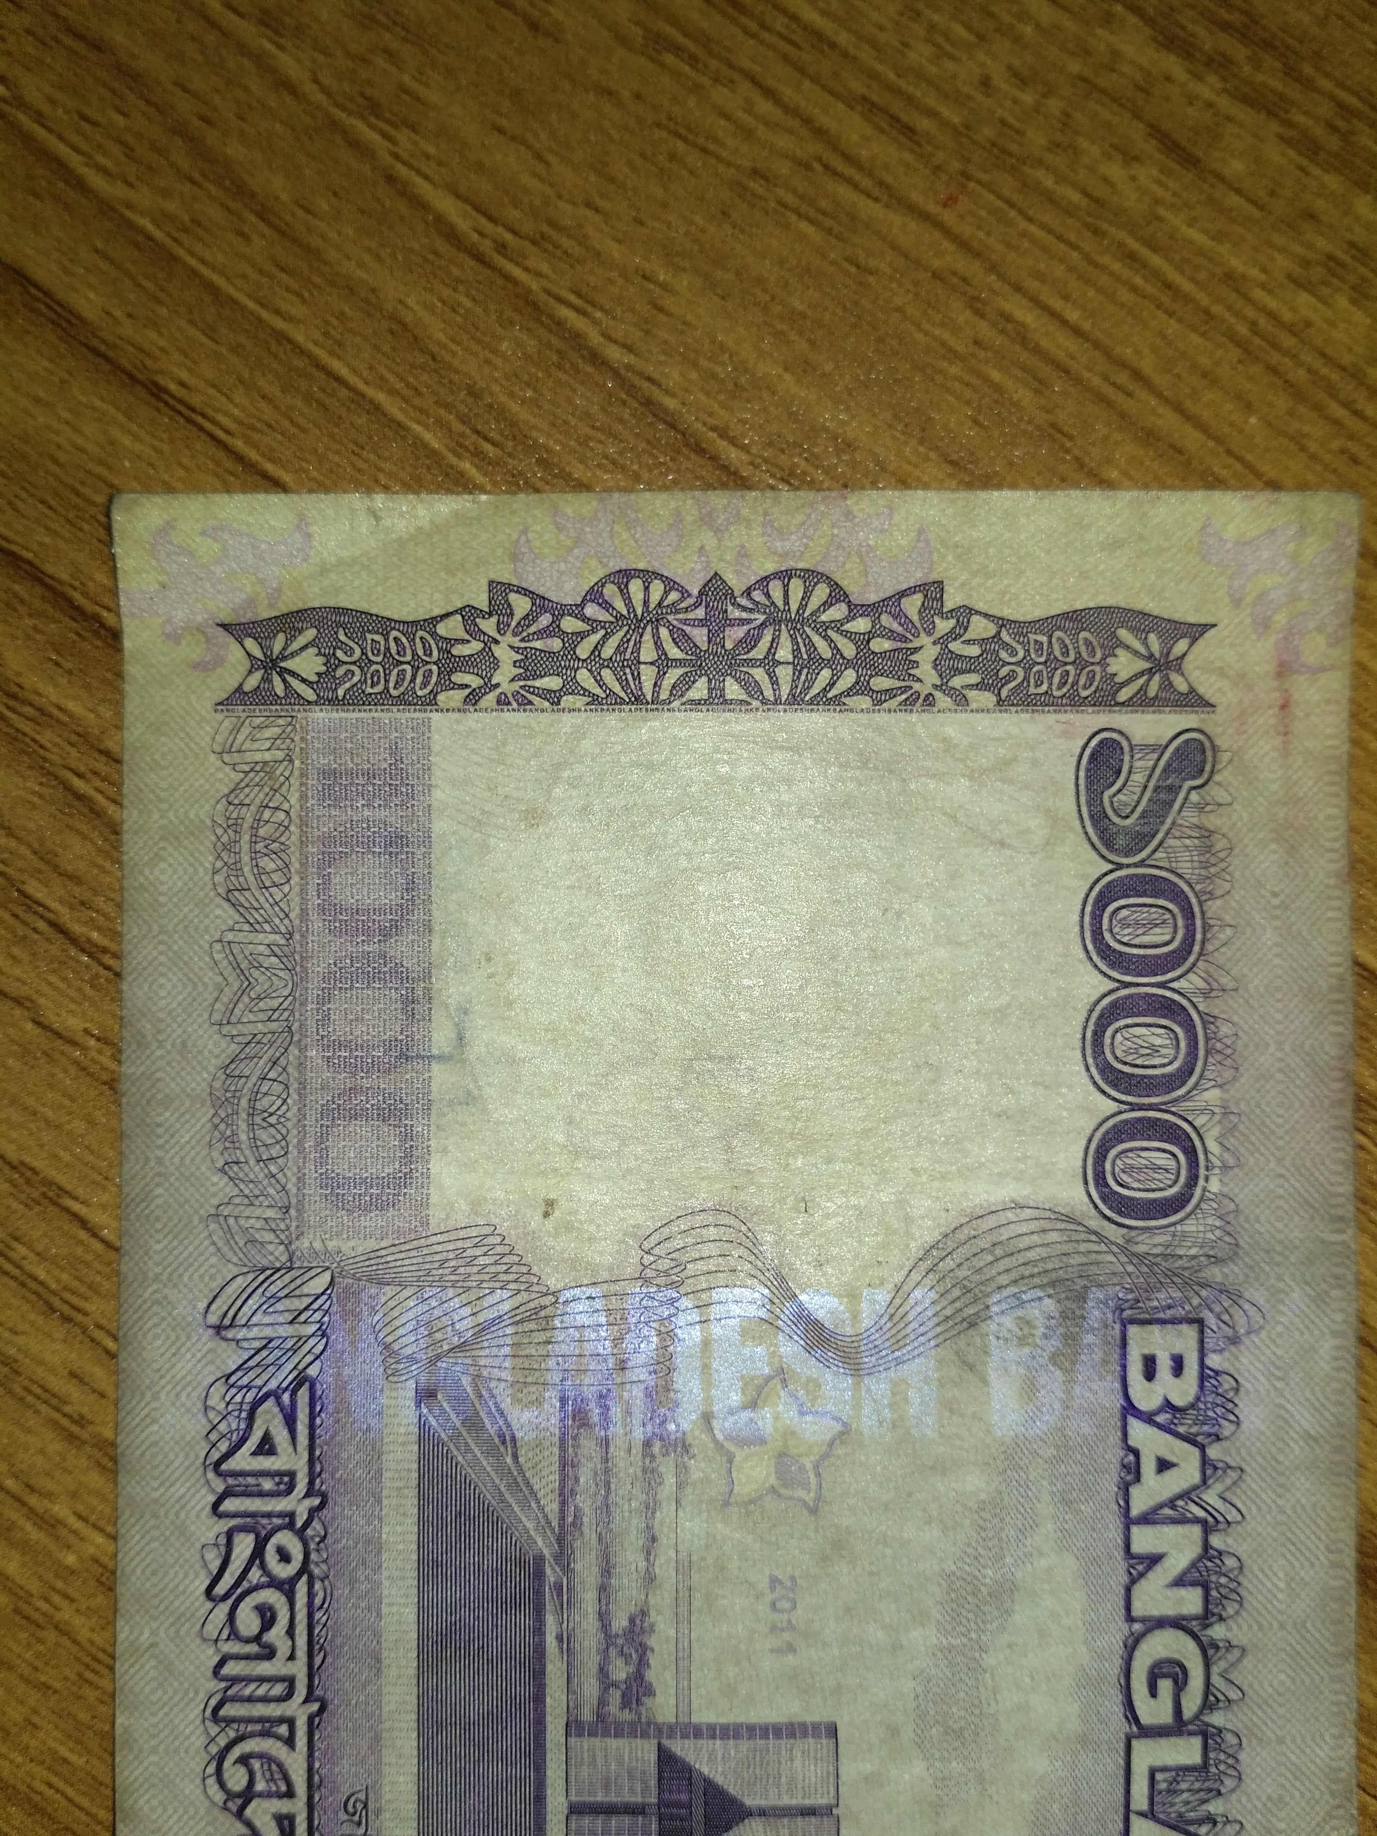

Orientation does not matter at all. But try to keep the portion that has been shown earlier, inside the frame as good as possible. If your camera has the ability to focus on a certain point, then focus it on the portion shown in red boundary below.

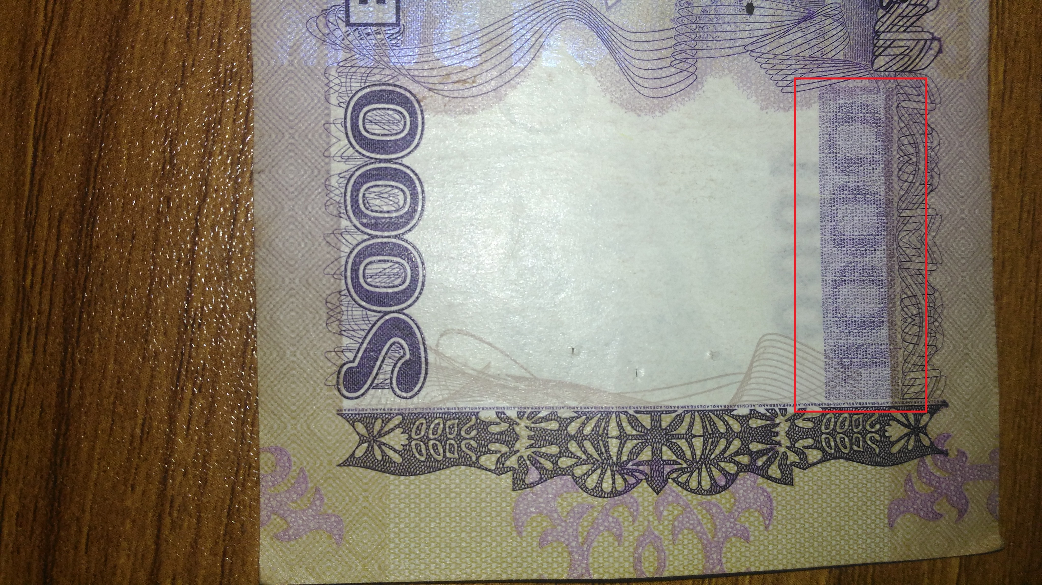

4. For BDT 1000 back side image, this application analyses 2 features. You can view those features using and buttons.

